**CLOUD COMPUTING**

**TECHNICAL REPORT WRITING (CM)**

Spring 2021



**Submitted To:** Sir Mudassir Jalal

**Department of Computer Science**

Mohammad Ali Jinnah University

Lal Kothi Bus Stop, Main Shahrah-e-Faisal, 22-E, Block-6, PECHS, Karachi-75400

<https://www.jinnah.edu>

# ACKNOWLEDGMENT

We are really thankful to our teacher Sir Mudassir jalal for giving us the chance to present ourselves and does some research work regarding the latest technology in IT.

At the same time his lectures in the class have been very informative and help us to understand about IT. We are also like to thanks all our colleagues and their efforts for providing us full support, encouragement and valuable guidance.

Sincere regards

**Usama Saleem (**FA19-BSCS-0046**)**

**Muhammad Talha Malik (**FA19-BSCS-0052**)**

**Ali Hassan Kazmi (**FA19-BSCS-0003**)**

Table of Contents

|  |  |
| --- | --- |
| Introduction | 4 |
| History | 6 |
| Cloud computing | 9 |
| Characteristics of cloud computing | 11 |
| Types of cloud computing | 13 |
| Deployment Tools | 17 |
| Where is the cloud going | 19 |
| Why Now | 20 |
| Benefits of cloud computing | 22 |
| Disadvantages of cloud computing | 24 |
| Challenges face by cloud computing | 27 |
| Conclusion | 29 |
| Preparing for the future | 30 |
| Further Readings | 31 |



**Cloud Computing `**



**Introduction**:

Cloud computing is Internet based development and use of computer technology. In concept, it is a paradigm shift whereby details are abstracted from the users who no longer need knowledge of, expertise in, or control over the technology infrastructure "in the cloud" that supports them. It typically involves the delivery of dynamically scalable and often virtualized resources as a service over the Internet.

The term cloud is used as a symbol for the Internet. Typical cloud computing services provide common business applications online that are accessed from a web browser, while the software and data are stored on the servers.

These services are broadly divided into three categories: Infrastructure as a Service (IaaS), Platform as a Service (PaaS), and Software as a Service (SaaS). The name cloud computing was inspired by the cloud symbol that is often used to represent the Internet in flow charts and diagrams.

"Cloud Computing" refers to the use of Internet based computer technology for a variety of services. It is a style of computing in which virtualized resources are provided as a service over the Internet on a pay-peruse basis. All the costs associated with setting up a data center such as procuring a building, hardware, redundant power supply, cooling systems, upgrading electrical supply, and maintaining a separate Disaster Recovery site can be passed on to a third party vendor. Since the customer is charged only for computer services used, cloud computing costs are much less than others.

The cloud when combined with "computing," the meaning gets bigger and fuzzier. Some analysts and vendors define cloud computing narrowly as an updated version of utility computing: Virtual servers available

over

the

Internet.

Others go very broad,

Arguing

Anything

We

Consume

Outside

The

The

Firewall

Is

"In

Including

Cloud,"

Conventional

Outsourcing.

Cloud computing

comes into focus only

when we think about

what IT always needs:

a

way

to

increase

capacity

or

add

capabilities on the fly

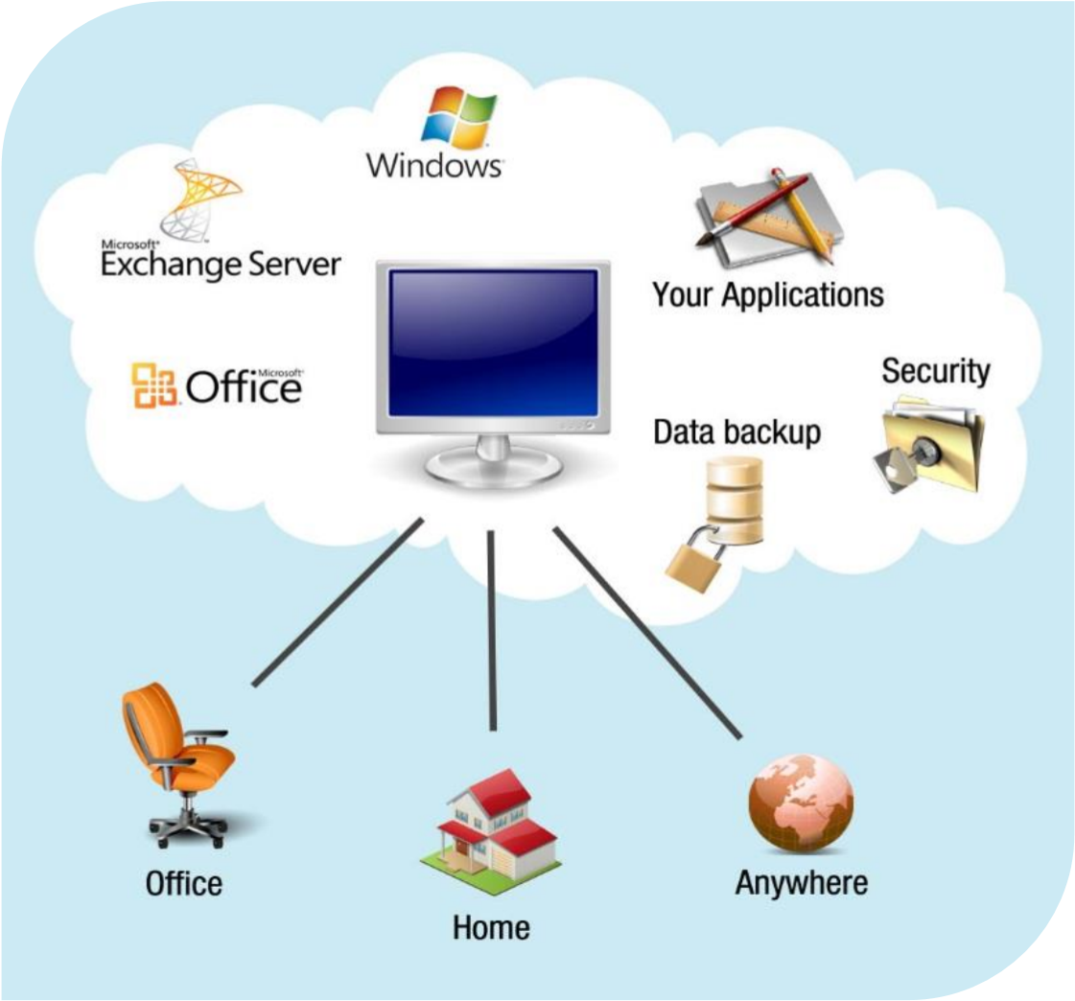

Without investing in new infrastructure, training new personnel, or licensing new software. Cloud computing encompasses any subscription-based or payper-use service that, in real time over the Internet, extends IT's existing capabilities.

**History:**

Computing started with the mainframe era. There were big mainframes and everyone connected to them via “dumb” terminals. This old model of business computing was frustrating for the people sitting at the dumb terminals because they could do only what they were “authorized” to do. They were dependent on the computer administrators to give them permission or to fix their problems. They had no way of staying up to the latest innovations.

The personal computer was a revolution against the dictatorship of centralized computing operations. There was a kind of freedom in the use of personal computers. But this was later replaced by server architectures with enterprise servers and others showing up in the industry. This made sure that the computing was done and it did not eat up any of the resources that one had with him. All the computing was perform at servers. Internet grew in the lap of these servers. With cloud computing we have come a full circle. We come back to the centralized computing infrastructure. However, this time it is something which can easily be accessed via the internet and something over which we have all the control.

In 1999, Salesforce.com was established by Marc Benioff, Parker Harris, and their associates. They applied many technologies developed by companies such as Google and Yahoo! to business applications. They also provided the concepts of "on demand" or SaaS with their real business and successful customers. The key for SaaS is that it is customizable by customers with limited technical support required. Business users have enthusiastically welcomed the resulting flexibility and speed.

In the early 2000s, Microsoft extended the concept of SaaS through the development of web services. IBM detailed these concepts in 2001 in the Autonomic Computing Program, which described advanced automation techniques such as self-monitoring, self-healing, self-configuring, and selfoptimizing in the management of complex IT systems with various storage, servers, applications, networks, security mechanisms, and other system elements that can be virtualized across an enterprise.

Amazon played a key role in the development of cloud computing by modernizing their data centers. Having found that the new cloud architecture resulted in significant internal efficiency improvements whereby, small, fast moving teams could add new features faster and easier, Amazon started providing access to their systems through Amazon Web Services on a utilit y computing basis in 2005.

In 2007, Google, IBM, and a number of universities embarked on a large scale cloud computing research project. By mid-2008, Gartner saw an opportunity for cloud computing "to shape the relationship among consumers of IT services, those who use IT services and those who sell them", and observed that" organizations are switching from company-owned hardware and software assets to per-use service-based models" so that the "projected shift to cloud computing ... will result in dramatic growth in IT products in some areas and in significant reductions in other areas."

Common used measureable parameters (upon which the application is charged for):

* CPU Usage.
* External network usage (the amount of data transferred from and to the server).
* Data transactions (the no. of transactions and the amount of data sent/received).

**Few terms you should understand before moving on**…

**Cloud Platform:**

Cloud platform is a kind of platform that lets developers write applications that run in the cloud, or use services provided from the cloud, or both. Different names are used for this kind of platform today, including ondemand platform and platform as a service (PaaS).

**Cloud Storage:**

It’s a method of managing our data (files, photos, music, video, whatever, etc…) from one or more web based solutions. Rather than keeping our data primarily on hard drives that are secured to our computers or other devices, we keep it “in the cloud” where it may be accessible from any number of devices.

**Cloud Infrastructure:**

Cloud Infrastructure is the concept of providing `hardware as a service` i.e. shared/reusable hardware for a specific time of service. Example includes virtualization. This service helps reduce maintenance and usability costs, considering the need for infrastructure management & upgrade.

**Cloud Services:**

A Cloud Service is an independent piece of software which can be used in conjunction with other services to achieve an interoperable machine-tomachine interaction over the network. Examples include Amazon’s Simple Queue Service, Google maps, Amazon’s flexible payment service etc.

**Cloud Computing:**

As define...

“Cloud computing is the delivery of computing resources over the internet instead of your computer’s hard drive.”

* Access your information from anywhere at any time.
* Connects to the cloud via the Internet; runs applications and stores data.
* For example, many people use social networking sites or gmail, and these are cloud services.

What cloud computing does is to connect the capabilities of resources and make available these resources as a single entity which can be changed to meet the current needs of the user. The basis of cloud computing is to create a set of virtual servers on the available vast resource pool and give it to the clients. Any web enabled device can be used to access the resources through the virtual servers. Based on the computing needs of the client, the infrastructure allotted to the client can be scaled up or down.

From a business point of view, cloud computing is a method to address the scalability and availability concerns for large scale applications which involves lesser overhead. Since the resource allocated to the client can be varied based on the needs of the client and can be done without any fuss, the overhead is very low.

One of the key concepts of cloud computing is that as and when the amount of data increases, the cloud computing services can be used to manage the load effectively and make the processing tasks easier. In the era of enterprise servers and personal computers, hardware was the commodity as the main criteria for the processing capabilities depended on the hardware configuration of the server. But with the arrival of cloud computing, the service has changed to cycles and bytes - i.e. in cloud computing services, the users are charged based on the number of cycles of execution performed or the number of bytes transferred. The hardware or the machines on which the applications run are hidden from the user. The amount of hardware needed for computing is taken care of by the management and the client is charged based on how the user uses these resources.

Some major examples of cloud computing we're probably using:

[**Google Drive:**](http://www.pcmag.com/article2/0,2817,2403546,00.asp) This is a pure cloud computing service, with all the apps and storage found online. Drive is also available on more than just desktop computers; you can use it on tablets or on smartphones. In fact, all of Google's services could be considered cloud computing: Gmail, Google Calendar, Google Reader, Google Voice, and so on. Upgrade to Google Apps and you can use many of the above with your own domain name attached.

[**Apple iCloud:**](http://www.pcmag.com/article2/0,2817,2394611,00.asp) Apple's cloud service is primarily used for online storage and synchronization of your mail, contacts, calendar, and more. All the data you need is available to you on your iOS, Mac OS, or Windows device. iCloud also stores media files.

[**Amazon Cloud Drive:**](http://www.pcmag.com/article2/0,2817,2382825,00.asp) Storage at the big retailer is mainly for music, preferably MP3s that you purchase from Amazon. Hybrid services like Box, Dropbox, and Sugar Sync all say they work in the cloud because they store a synched version of your files online, but most also sync those files with local storage. Synchronization to allow all your devices to access the same data is a foundation of the cloud computing. Likewise, it's considered cloud computing if you have a community of people with separate devices that need the same data synched, be it for work collaboration projects or just to [keep the family in sync.](http://www.pcmag.com/article2/0,2817,2403025,00.asp)

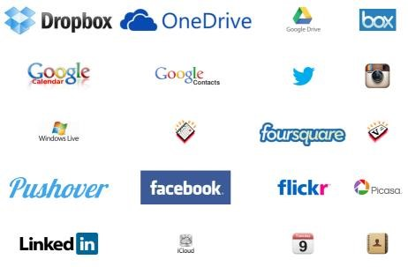

**Characteristics of Cloud Computing:**

1. **On-Demand Self-Service:**

A consumer can unilaterally provision computing capabilities, such as server time and network storage, as needed automatically without requiring human interaction with each service provider. Establish, manage and terminate services on your own, without involving the cloud service provider.

1. **Broad Network Access:**

Cloud computing simply means network access from just about anywhere worldwide. Use a standard web browser to access the user interface, without any software add- ons or specific OS requirements. You just need to log in to your account using an internet connection in order to extract the important information from the service provider’s website. This is an important feature of cloud computing as it really helps in generating the best possible results.

1. **Resource Pooling:**

Resource pooling is an IT term used in cloud computing environments to describe a situation in which providers serve multiple clients, customers or "tenants" with provisional and scalable services. These services can be adjusted to suit each client's needs without any changes being apparent to the client or end user.

It share resources and costs across a large pool of users, allowing for centralization and increased peak load capacity. The provider’s computing resources are pooled to serve multiple consumers using a multi-tenant model, with different physical and virtual resources dynamically assigned and reassigned according to consumer demand.

This is the practice of permitting several clients to knock into a single pool of servers or disk storage or other type of specific resource.

We know that chances of all the users logging into the account at once are really low and this is the reason why the company manages everything through resource pooling.

1. **Rapid Elasticity:**

Leverage capacity as needed, when needed, and give it back when it is no longer required. Capabilities can be rapidly and elastically provisioned. To the consumer, the capabilities available for provisioning often appear to be unlimited and can be purchased in any quantity at any time. Companies sometimes require additional resources in a small period of time and this is where cloud computing comes in to play. For example, in case a firm gets a fresh client and needs three extra servers to meet up the customer’s business requirements, the service provider could permit the firm to uphold three different servers at a time.

1. **Measured Service:**

Consume resources as a service and pay only for resources used. Cloud systems automatically control and optimize resource use by leveraging a metering capability at some level of abstraction appropriate to the type of service (e.g., storage, processing, bandwidth, and active user accounts). Resource usage can be monitored, controlled, and reported, providing transparency for both the provider and consumer of the utilized service.

The best thing about cloud computing is that it comes with a pay per use feature. This is the reason why more and more companies are choosing it for the purpose of storage. The usage fee of cloud computing is never a big problem for the enterprises as you just need to pay for the services that you make use of. You don’t need to pay in advance and thereby block your money. Once you use it for a specific period of time, you will just have to pay for that amount of time.

**Types of Cloud Computing:**

Cloud computing can describe services being provided at any of the traditional layers from hardware to applications. In practice, cloud service providers (CSP’s) tend to offer services that can be grouped into three categories: software as a service, platform as a service, and infrastructure as a service.

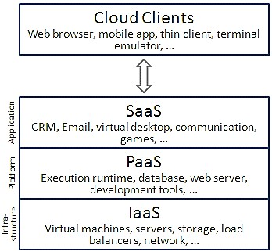

**Software as a Service (SaaS):**

* Provides the same software to different customers via a network, usually the Internet.
* Managed by third party venders
* Accessible via any computer without any downloads • Pay only for what you used.

Software as a service features a complete application offered as a service on demand. The most widely known example of SaaS is salesforce.com, though many other examples have come to market, including the Google drive offering of basic business services including email and word processing. Although salesforce.com preceded the definition of cloud computing by a few years, it now operates by leveraging its companion force.com, which can be defined as a platform as a service.

**Platform as a Service (PaaS):**

* Offer an Internet-based platform to developers who want to create services and application but don't want to build their own cloud.
* No need to buy hardware and software.
* Servers, storage and networking managed by third party venders.
* Rapid development at low cost.

Someone producing PaaS might produce a platform by integrating an OS, application software, and even a development environment that is then provided to a customer as a service. The customer interacts with the platform through the API, and the platform does what is necessary to manage and scale itself to provide a given level of service. Virtual appliances can be classified as instances of PaaS. A content switch appliance, for example, would have all of its component software hidden from the customer, and only an API for configuring and deploying the service provided to them.

PaaS offerings can provide for every phase of software development and testing, or they can be specialized around a particular area such as content management. Commercial examples of PaaS include the

Google Apps Engine, which serves applications on Google’s infrastructure. PaaS services such as these can provide a powerful basis on which to deploy applications, however they may be constrained by the capabilities that the cloud provider chooses to deliver.

**Infrastructure as a Service (IaaS):**

* Allows applications to be run on a cloud supplier’s hardware by allows you to install a virtual server on their IT infrastructure.
* No need to purchase servers, or network equipment.
* Servers, storage and networking managed by venders.
* Applications and updates managed by users.
* Usually billed based on usage.

Infrastructure as a service delivers basic storage and compute capabilities as standardized services over the network. Servers, storage systems, switches, routers, and other systems are pooled and made available to handle workloads that range from application components to highperformance computing applications. Commercial examples of IaaS include Joyent, whose main product is a line of virtualized servers that provide a highly available on-demand infrastructure.

**Examples**:

## Salesforce.com

Salesforce.com is one of the pioneers of the software as a service (SaaS) model of distributing business software, in which access to business software is purchased on a subscription basis and hosted offsite. They are best known for their Customer Relationship Management (CRM) products, which it delivers to businesses over the internet using the SaaS model. Salesforce.com has its services translated into 16 different languages and currently has thousands of customers and over millions subscribers.

### Force.com Cloud Platform

With Force.com, we can build and deliver applications 5 times faster, at about ½ the cost of traditional software platforms. We deliver a complete platform with a simplified programming model so just about anyone can use it to build apps.

## Google App

Google app is a service from Google for using custom domain names with several Google products. It features several Web applications with similar functionality to traditional office suites, including: Gmail, Google Calendar, Talk, Docs and Sites.

Google app is innovative tools provided by Google that can help small business firms, Non-Profit Organizations, Corporate houses and Educational institutions in their day to day functioning and also help to take the organization to the next level. Many schools and universities are making use of Google app to facilitate better co-ordination among students, staff and faculty. For small business firms it helps improve collaboration and communication among employees and helps them work faster and more efficiently.

**Deployment Models:**

Deploying cloud computing can differ depending on requirements, and the following four deployment models have been identified, each with specific characteristics that support the needs of the services and users of the clouds in particular ways. Theses deployment models are based on customer needs and demands.

**Public Cloud:**

Cloud infrastructure which can be accessed by any subscriber, run by third parties and gives different application on the cloud’s servers, reduce customer risk and cost by providing temporaryextensionto enterprise infrastructure. The cloud infrastructure is available to the public on a commercial basis by a cloud service provider. This enables a consumer to develop and deploy a service in the cloud with very little financial outlay compared to the capital expenditure requirements normally associated with other deployment options.

**Private Cloud:**

Cloud infrastructure that’s maintained and operated for specific client. Access limited to that client with utmost control over data, security and quality of services and operation may be in-house or third party on the premises.

**Hybrid Cloud:**

Combination of public and private cloud models with ability to allow data to move from one cloud to another and that is used to maintain service level in the face of workload fluctuation with leverage cloud solutions for specific functions that are costly to maintain on premise i.e. backups and test/development environments. The cloud infrastructure consists of a number of clouds of any type. This can be a combination of private and public clouds that support the requirement to retain some data in an organization, and also the need to offer services in the cloud.

**Community Cloud:**

Shared among number of groups with similar cloud requirement. Help them to limit cost of cloud’s establishment due to sharing among groups with operation may be in-house or third party on the premises. Costs are spread over fewer users than a public cloud but more than a single tenant.

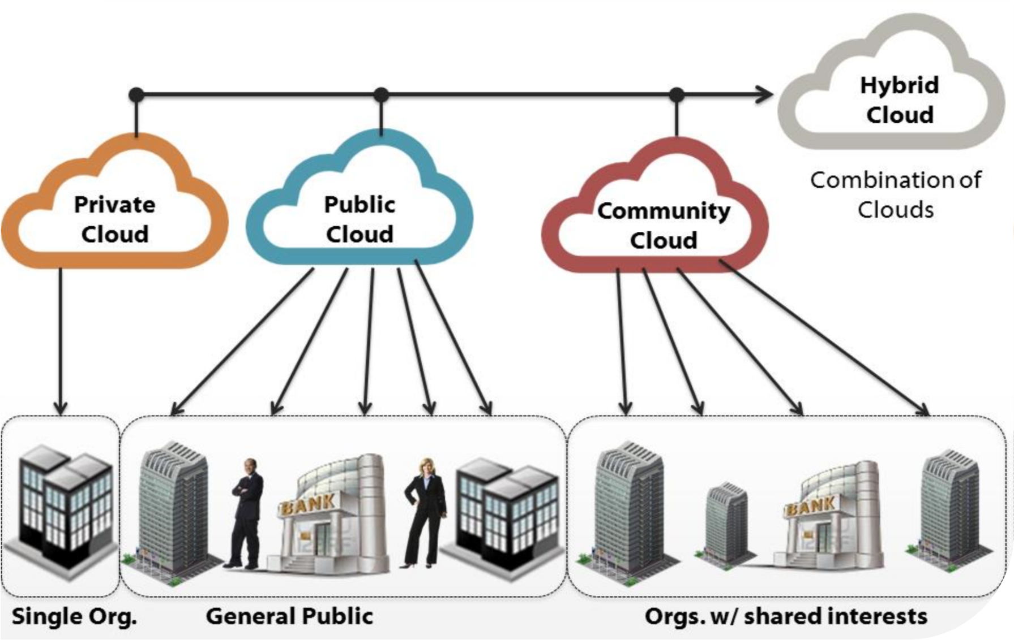

**Where is the Cloud Going?**

* IDC's updated IT Cloud Services Forecast predicts that public cloud computing will grow from $17.4 billion worth of IT spend in 2009 to $44 billion by 2013.
* Additionally, Federal CIO Vivek Kundra has vowed to spend $19 billion of U.S. government's $70 billion IT budget on cloud computing.
* The five year growth outlook remains strong, with a five-year annual growth rate of 26% – over six times the rate of traditional IT offerings.

Above figures shows that cloud computing is getting popularity among consumers, due to low cost, rapid elasticity, scalability and security.

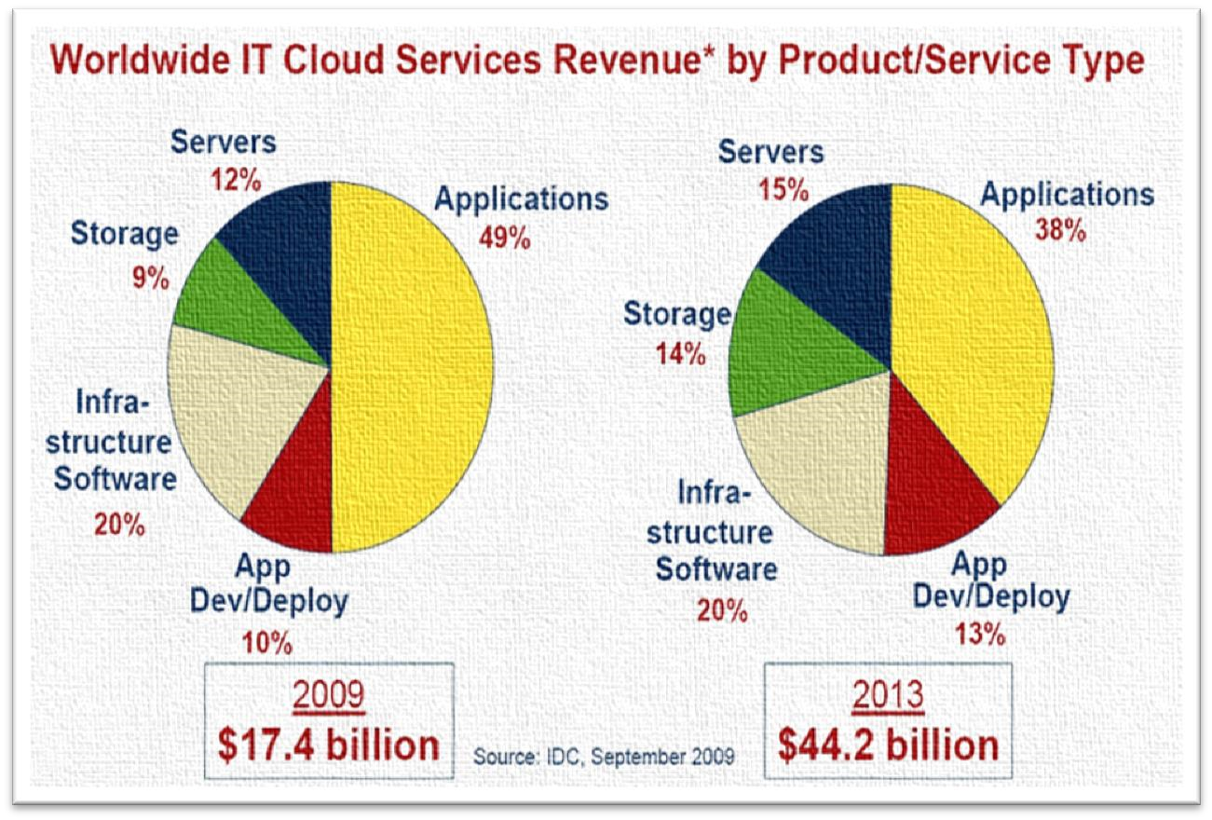

**Why Now:**

* The acceptance and increase of hardware virtualization and multitenant applications.
* The Internet has become everywhere and an accepted method of connecting providers with consumers.
* ISPs / Telco’s are offering robust, redundant and managed corporate internet service enabling service consolidation efficiencies.
* The cost verses risk equation has tipped toward shared solutions.
* Computing capabilities are being seen as an ongoing service rather than an internal capital expense.

**Re-allocate IT expenditures:**

DATA CENTER COSTS



Deploy

10

%



Operate

25

%



Support

10

%



Facilities

7

%



Network

11

%



SW

9

%



%

50

Labor Expense



**Cloud**

**Computing reduces**

**Labor costs**



**Cloud Computing reduces**

**Facilities, Network,**

**Hardware, Software**

**maintenance costs**

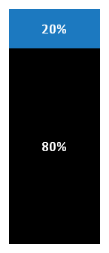

%

50

Other

Expenses

**Enterprise Cloud Solutions:**

1. Hybrid Cloud:
   * Scalability of the Public Cloud with the control and security of a private cloud is the best cloud solution for enterprises.
2. Test / Development / QA Platform:
   * Use cloud infrastructure servers as their test and development platform.
3. Disaster Recovery:
   * Keep images of your servers on cloud infrastructure ready to go in case of a disaster.
4. Cloud File Storage:
   * Backup or Archive your company data to cloud file storage.
5. Load Balancing:
   * Use cloud infrastructure for overflow management during peak usage times.
6. Overhead Control:
   * Lower overhead costs and make your bids more competitive.
7. Distributed Network Control and Cost Reporting:
   * Create an individual private networks for each of your subsidiaries or contracts.
8. Messaging Alternatives:
   * Replace Microsoft Exchange and SharePoint with Google Apps.
9. Rapid Deployment:
   * Turn up servers immediately to fulfill project time lines.
10. Functional IT Labor Shift:
    * Refocus your IT labor expense on revenue producing activities.

So far in this report we have highlighted the type of service offered by cloud and its deployment models. Now we consider its benefits, weaknesses and challenges face by cloud computing.

**Benefits of Cloud Computing:**

The following are some benefits of cloud computing-based services and applications:

**Cost Saving:**

The most important benefit one can get by using cloud computing is cost saving and especially this has work really well for small sized companies. Companies can reduce their capital expenditures and use operational expenditures for increasing their computing capabilities. This is a lower barrier to entry and also requires fewer in-house IT resources to provide system support.

**Reduced time for implementation:**

Cloud computing provides the processing power and data storage as needed at the capacity required. This can be obtained in real time instead of weeks or months that occur when a new business initiative is brought online in a traditional way.

**Dynamic scalability:**

Many enterprises include a reasonably large buffer from their average computing requirement, just to ensure that capacity is in place to satisfy peak demand. Cloud computing provides an extra processing buffer as needed at a low cost and without the capital investment or contingency fees to users.

**Shortened development life cycle:**

Cloud computing adopts the shorter development life cycle that required by the traditional development approach. Any new business application can be developed online, connecting proven functional application building blocks together.

**Reliability:**

Services using multiple redundant sites can support business continuity and disaster recovery.

**Maintenance:**

Cloud service providers do the system maintenance, and access is through application programming interfaces that do not require application installations onto PCs, thus further reducing maintenance requirements.

**Mobile Accessible:**

Mobile workers have increased productivity due to systems accessible in an infrastructure available from anywhere.

**Monitor projects more effectively:**

Stay within budget and ahead of completion cycle times. This option is really helpful for small companies or individual as they use the resources according to their requirement and keeping in mind their projected budget.

**Less personnel training is needed:**

It takes fewer people to do more work on a cloud, with a minimal learning curve on hardware and software issues. This result in less spending on infrastructure and company would spend more on their projects.

**Minimize licensing new software:**

Stretch and grow without the need to buy expensive software licenses or programs. Cloud does not require you to buy hardware and software because all the maintenance will be look after by the venders.

**Disadvantages of Cloud Computing:**

As you explore your cloud computing options, a few disadvantages to be aware of include:

**More elasticity means less control:**

While public clouds are great for quickly scaling up and down your resources, companies that require complete and total control over their data and applications will need to avoid the public cloud. Alternative solutions include hybrid clouds, private clouds.

**Not everything fits into the cloud:**

Depending on the cloud provider, you may face restrictions on available applications, operating systems, and infrastructure options. Complicating matters more is the simple fact that not all platforms can live in the cloud. To combat this, it is important to ensure that the cloud provider you choose also offers physical services. Then if your platform in the cloud needs to speak to applications on other platforms, this flexibility of physical collocation will work to ensure successful interoperation.

**Data location**:

Cloud computing technology allows cloud servers to reside anywhere, thus the enterprise may not know the physical location of the server used to store and process their data and applications. Although from the technology point of view, location is least relevant, this has become a critical issue for data governance requirements. It is essential to understand that many Cloud Service Providers (CSPs) can also specifically define where data is to be located.

**Data Safety:**

Application sharing and multi-tenancy of data is one of the characteristics associated with cloud computing. Although many CSPs have multi-tenant applications that are secure, scalable and customizable, security and privacy issues are still often concerns among enterprises. Data encryption is another control that can assist data confidentiality.

**Cloud security policy / procedures transparency**:

Some CSPs may have less transparency than others about their information security policy. The rationalization for such difference is the policies may be proprietary. As a result, it may create conflict with the enterprise’s information compliance requirement. The enterprise needs to have detailed understanding of the service level agreements (SLAs) that stipulated the desired level of security provided by the CSPs.

**Cloud date ownership**:

In the contract agreements it may state that the CP owns the data stored in the cloud computing environment. The CSP may demand for significant service fees for data to be returned to the enterprise when the cloud computing SLAs terminates.

**Lock-in with CSP’s application programming interfaces:**

Currently many CSPs implement their application by adopting the

APIs. As a result, cloud services transition from one CSP to another CSP, has become extremely complicated, time-consuming and labor-intensive.

**Disaster recovery**:

It is a concern of enterprises about the resiliency of cloud computing, since data may be commingled and scattered around multiple servers and geographical areas. It may be possible that the data for a specific point of time cannot be identified. Unlike traditional hosting, the enterprise knows exactly where the location is of their data, to be rapidly retrieved in the event of disaster recovery. In the cloud computing model, the primary CSP may outsource capabilities to third parties, who may also outsource the recovery process. This will become more complex when the primary CSP does not ultimately hold the data.

**Challenges face by Cloud Computing:**

The following are some of the notable challenges associated with cloud computing, and although some of these may cause a slowdown when delivering more services in the cloud, most also can provide opportunities, if resolved with due care and attention in the planning stages.

**Security and Privacy:**

Perhaps two of the more “hot button” issues surrounding cloud computing relate to storing and securing data, and monitoring the use of the cloud by the service providers. The information housed on the cloud is often seen as valuable to individuals with malicious intent. There is a lot of personal information and potentially secure data that people store on their computers, and this information is now being transferred to the cloud. This makes it critical for you to understand the security measures that your cloud provider has in place, and it is equally important to take personal precautions to secure your data.

The first thing you must look into is the security measures that your cloud provider already has in place. These vary from provider to provider and among the various types of clouds. What encryption methods do the providers have in place? What methods of protection do they have in place for the actual hardware that your data will be stored on? Will they have backups of my data? Do they have firewalls set up? If you have a community cloud, what barriers are in place to keep your information separate from other companies?

Many cloud providers have standard terms and conditions that may answer these questions, but the home user will probably have little negotiation room in their cloud contract. A small business user may have slightly more room to discuss the terms of their contract with the provider and will be able to ask these questions during that time. There are many questions that you can ask, but it is important to choose a cloud provider that considers the security of your data as a major concern.

No matter how careful you are with your personal data, by subscribing to the cloud you will be giving up some control to an external source. This distance between you and the physical location of your data creates a barrier. It may also create more space for a third party to access your information. However, to take advantage of the benefits of the cloud, you will have to knowingly give up direct control of your data. On the converse, keep in mind that most cloud providers will have a great deal of knowledge on how to keep your data safe. A provider likely has more resources and expertise than the average user to secure their computers and networks.

**Lack of Standards:**

Clouds have documented interfaces; however, no standards are associated with these, and thus it is unlikely that most clouds will be interoperable. The Open Grid Forum is developing an Open Cloud Computing Interface to resolve this issue and the Open Cloud Consortium is working on cloud computing standards and practices. The findings of these groups will need to mature, but it is not known whether they will address the needs of the people deploying the services and the specific interfaces these services need. However, keeping up to date on the latest standards as they evolve will allow them to be leveraged, if applicable.

**Continuously Evolving:**

User requirements are continuously evolving, as are the requirements for interfaces, networking, and storage. This means that a “cloud,” especially a public one, does not remain static and is also continuously evolving.

**Compliance requirements:**

Today’s cloud computing services can challenge various compliance audit requirements currently in place. Data location; cloud computing security policy transparency; are all challenging issues in compliance auditing efforts. Examples of the compliance requirement including privacy laws and financial reporting laws.

**Conclusion:**

Cloud Computing is outpacing the IT industry.

* Customers of all sizes can realize real business value.
* Cloud solutions are simple to acquire, do not require long term contracts and are easier to scale up and down as needed.
* Proper planning and migration services are needed to ensure a successful implementation.
* Public and Private Clouds can be deployed together to leverage the best of both.
* Third party monitoring services ensure customer are getting the most out of their cloud environment.
* Security Compliance and Monitoring is achievable with careful planning and analysis.

To summarize, the cloud as mentioned above provides many options for the everyday computer user as well as large and small businesses. It opens up the world of computing to a broader range of uses and increases the ease of use by giving access through any internet connection. However, with this increased ease also come drawbacks. You have less control over who has access to your information and little to no knowledge of where it is stored. You also must be aware of the security risks of having data stored on the cloud. The cloud is a big target for malicious individuals and may have disadvantages because it can be accessed through an unsecured internet connection.

If you are considering using the cloud, be certain that you identify what information you will be putting out in the cloud, who will have access to that information, and what you will need to make sure it is protected. Additionally, know your options in terms of what type of cloud will be best for your needs, what type of provider will be most useful to you, and what the reputation and responsibilities of the providers you are considering are before you sign up.

**Preparing for the Future:**

Sampling of IT skills likely to be in demand in the future:

• Functional application development and support.

▪ I.e. Oracle, SAP, SQL, linking hardware to software.

* Leveraging data to make strategic business decisions.
  + I.e. Business Intelligence : Applying sales forecasts to inventory and manufacturing decisions.
* Mobile apps.
  + Android, iPhone, Windows Mobile.
* WiFi engineers.
  + USF to include broadband communications (LTE replaces GSM/CDMA).
* Optical engineers.
  + Optical offers the highest bandwidth today (PON, CWDM, DWDM).
* Virtualization Specialists.
  + Economies of scale require virtualization (server, storage, client…).
* IP Engineers.
* Network Security Specialists.
* Web developers.
* Social Media developers.
* Business Intelligence application development and support.

**Further Reading:**

1. Lewis, Grace*. Cloud Computing: Finding the Silver Lining, Not the*

*Silver Bullet*. http://www.sei.cmu.edu/newsitems/cloudcomputing.cfm (2009).

1. Lewis,Grace. *Basics about Cloud Computing*. http://www.sei.cmu.edu/library/abstracts/whitepapers/cloudcomputingb asics.cfm (2010).

1. Jansen, Wayne & Grance, Timothy. *Guidelines on Security and Privacy in Public Cloud Computing.* National Institute of Standards and Technology, 2011.
2. Strowd, Harrison & Lewis, Grace. *T-Check in System-of-Systems Technologies: Cloud Computing* (CMU/SEI-2010-TN-009). Software Engineering Institute, Carnegie Mellon University, 2010. http://www.sei.cmu.edu/library/abstracts/reports/10tn009.cfm.